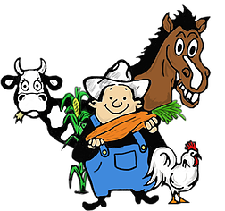Timmins Fall Fair

**September** 9 & 10th, 2023

Mountjoy Arena

814 Park Ave., Timmins, Ontario

Porcupine District 14 Agricultural Society

P.O. Box 263

Timmins, Ontario

P4N 7E2

***www.timminsfallfair.ca***

[***fallfaireveryone@hotmail.c***](mailto:fallfaireveryone@hotmail.c)***om***

***Doors open to public***

**SATURDAY** 9am to 6pm

**SUNDAY** 9am to 4pm

**Message from the President**

As president of the Porcupine District

Agricultural Society, I look forward to working

with a dedicated team of directors, volunteers

and sponsors. Providing such a great event

allows us to showcase local agriculture

and talent that bring the community

together each September.

Come and see how we always improve the fair.

Hope you enjoy all the activities that the

Fall Fair 2023 has to offer.

Let's grow together!

**Rock Whissell**

**RULES & REGULATIONS**

*All exhibitors must register at the arena office to receive their exhibitor number on **\*\*\*Thursday *Sept.7th* between 6pm and 9pm*** on the week of the fair. Registration is FREE.**

**ALL EXHIBITORS MUST BE OFF THE FLOOR BY 9PM SHARP.**

*All exhibitors must have their name, address, exhibitor number, section and class identified on their exhibit tag.

**ONLY ONE ENTRY per CLASS per EXHIBITOR is accepted.**

*No mark, initial or name will be visible on the item exhibited until the prizes are awarded.

*All vegetable, fruit and flower entries must be grown by the exhibitor. All entries must be the work of the person who is entering it.

*Upon fraud, deception or dishonest practice, the Directors shall have the power to withhold the payment to the proven guilty of such an offense.

*Apart from Directors, no one will be allowed in the judging area while the judging is taking place and any exhibitor violating this rule shall forfeit his or her right to any prize to which he or she may be entitled.

*The judges’ decisions will be final and no protests will be accepted. In the absence of competition in any section, or if the entry be of inferior quality, judges must award the entry only such prizes as they deem the entry worthy of.

*New classes must have three or more entries before becoming a class the following year.

**\*ALL ENTRIES MUST BE PICKED UP BY THE EXHIBITOR ON SUNDAY between 4:00-4:30PM.** Anyone removing their exhibits before this time will forfeit all prizes coming to them.

*The directors will not be responsible for any exhibit left in the building after 4:30pm on Sunday.

*The PDAS will not be responsible for any loss or damage to animals, exhibits or injury to any exhibitor or spectator.

C:\Users\Therese 2\AppData\Local\Microsoft\Windows\Temporary Internet Files\Content.IE5\DY69DZSZ\MC900379495[1].wmf*While the Directors will take every reasonable precaution to insure the safety of animals and items being exhibited, it is distinctly understood that owners must take the risk of exhibiting them. Should any animal or item be lost, stolen, injured or strayed, the Directors will give assistance towards their recovery. No payment, in whole or in part value, shall be made in such circumstances. The Directors will take every precaution to prevent accidents, but will not hold themselves responsible for any accidents on the fairgrounds or buildings. ***Please note* All cheques must be cashed before**

**December 30th of the current year.**

**AWARDS**

**Certificates from Judges’ Choice** will be awarded as follows:

***SECTION 1 Grain & Seeds SECTION 18 to 20 Crafts & hobbies(jr)***

***SECTION 2 & 3 Vegetables & Fruits SECTION 21 Photography***

***SECTION 4 Vegetables & Fruits (jr) SECTION 22 & 24 Baking (jr)***

***SECTION 5 Honey & Eggs SECTION 23, 25 to 28 Home baking***

***SECTION 6 Flowers SECTION 29 Canning***

***SECTION 7 to 11, 13 to 15 Handcrafts SECTION 30 Poultry, rabbits, ducks***

***SECTION 12 Championship Quilt SECTION 31 Goats, sheep, hogs***

***SECTION 16 & 17 Home crafts (adult) SECTION 32 Livestock***

***We would like to wish all of our exhibitors the***

**BEST OF LUCK**

PRIZES for all classes (unless posted)

1st - $5

2nd - $4

3rd - $3

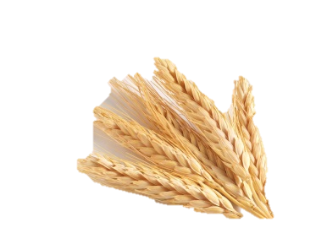

**SECTION 1 – GRAINS & SEEDS**

CLASS 1 – One sheaf of oats

CLASS 2 – One sheaf of barley

CLASS 3 – Wheat, any variety

CLASS 4 – Oats

CLASS 5 – Barley

CLASS 6 – Hay, section of bale 8-10 in

CLASS 7 – Any other grains

**RULE:**

Sheaves of grain will remain the property of the Society. Grain should not be older than one year. Each sheaf must be 5in. to 7in. in diameter. It must be neatly tied.

**SECTION 2 – FIELD GROWN VEGETABLES & FRUITS**

CLASS 1 – Potatoes, coloured or warba (3) per

variety)

CLASS 2 – Potatoes, any white variety (3)

CLASS 3 – Potatoes, any red variety (3)

CLASS 4 – Potatoes, sweet or yams (3)

CLASS 5 – Beans, any type with stem (3 pods)

CLASS 6 – Beets, round or long, 1 in. of top (3)

CLASS 7 – Cabbage, any type, show outer leaves (1)

CLASS 8 – Carrots, long or short (3)

CLASS 9 – Celery, any variety (1 whole stalk)

CLASS 10 – Corn with husk (2 husks)

CLASS 11 – Cucumber, green, with stem (2)

CLASS 12 – Cucumber, pickling, with stem (2)

CLASS 13 – Kohlrabi (1)

CLASS 14 – Onions, grown from seeds (3)

CLASS 15 – Onions, grown from set (3)

CLASS 16 – Parsnips (3)

CLASS 17 – Peas, any type, round or flat (3 pods)

CLASS 18 – Pumpkin (1)

CLASS 19 – Tomatoes, ripe, stem to show (3)

CLASS 20 – Tomatoes, green, stem to show (3)

CLASS 21 – Cherry Tomatoes on one vine

CLASS 22 – Turnips, any variety (1)

CLASS 23 – Parsley, bunch with roots, in water (1)

CLASS 24 – Squash, any colour (1)

CLASS 25 – Cucumber, English Burpless over 6 in. (1)

CLASS 26 – Vegetable of any type

CLASS 27 – Fruit of any type

CLASS 28 – Garlic (1 whole bulb with root, thin neck

attached)

CLASS 29 – Herbs, any variety, bunch in water (2)

CLASS 30 – Swiss chard (1)

CLASS 31 – Rhubarb, base not trimmed (3 stalks)

CLASS 32 – Crab apples, stem to show (3)

CLASS 33 – Sunflower (1)

CLASS 34 – Kale (1)

CLASS 35 – Peppers, any colour, with stem (2)

CLASS 36 – Zucchini with stem, 8 to 10 in. (1)

CLASS 37 – Zucchini longest over 10” (1)

**HINTS:**

Tomatoes – leave stem on – matched

Pumpkin, squash – leave stem attached-matched

Peppers – leave half-inch stem

Onions – do not peel or wash, just remove outer skin, leave tops at 1 in. above bulb

Carrots – leave 1/2 in. top, tap root left on, wash lightly

Beets – leave 1 in. above crown, roots trimmed

back to no less than 1 in.

Cucumbers – leave 1/4 of an inch stem

Cabbage – some outer leaves should be left on

Corn – 1/3 of husk removed from tip to butt

Potatoes – may be washed with soft cloth

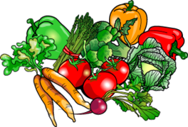

**SECTION 3 – GREEN HOUSE GROWN VEGETABLES**

CLASS 1 – Cherry tomatoes with stem (6)

CLASS 2 – Tomatoes, ripe with stem (3)

CLASS 3 – Most ripe tomatoes on a truss (vine)

CLASS 4 – Green tomatoes, with stem (3)

CLASS 5 – Cucumber, slicing, with stem (2)

CLASS 6 – Peppers, any colour, with stem (2)

CLASS 7 – Zucchini with stem, 8 to 10 in. (1)

CLASS 8 – Zucchini with stem, longest over 10” (1)

**SECTION 4 – JUNIOR VEGETABLE CLUB**

**(5 TO 16 YRS OLD)**

CLASS 1 – Sunflower (1)

CLASS 2 – Potatoes (3) may be washed

CLASS 3 – Carrots, short or long, with stem (3)

CLASS 4 – Beans, any type, with stem (3)

CLASS 5 – Human or Creature made from Vegetables

**BASICS IN JUDGING GARDEN VEGETABLES**

*Uniformity and trueness to type

*Excellent condition and colour

*Freshness/Blemishes/Scarring/Maturity

*Tenderness/Size/Texture/Appearance

*Flavour/Smell/Properly trimmed

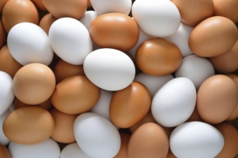

**SECTION 5 – HONEY & EGGS**

***HONEY***

CLASS 1 – Small jar of white honey (1)

**RULE:** All honey must be from bees owned by the exhibitor.

***EGGS***

CLASS 1 – Fresh brown eggs (1 dozen)

CLASS 2 – Fresh white eggs (1 dozen)

CLASS 3 – Fresh cream eggs (1 dozen)

CLASS 4 – Any other eggs

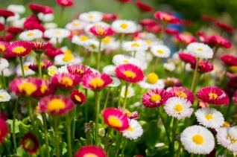

**SECTION 6 - FLOWERS**

CLASS 1 – Aster, any variety (3 blooms)

CLASS 2 – Coleus, any variety

CLASS 3 – Marigold, any variety (3 blooms)

CLASS 4 – Roses (3 blooms)

CLASS 5 – Petunias, any variety (3 blooms)

CLASS 6 – Pansies, giant mixed (3 blooms)

CLASS 7 – Annuals, any variety (3 blooms)

CLASS 8 – Dahlias (1 bloom)

CLASS 9 – Gladiola, mixed (3 spikes)

CLASS 10 – Begonia in bloom (potted)

CLASS 11 – African violets in bloom (potted)

CLASS 12 – Geranium in bloom (potted)

CLASS 13 – Any other potted plant

CLASS 14 – Arrangement of wild flowers

CLASS 15 – Any other perennial variety (3 blooms)

**HINT:** If you have no oasis or pin holders to hold your flower arrangement in place, try putting some beach sand, small or glass marbles in your vase.

**SECTION 7 - NEEDLEWORK**

CLASS 1 – Petit point finished item

CLASS 2 – Counted stitch item

CLASS 3 - Crewel embroidery item

CLASS 4 - Miscellaneous

CLASS 5 – Rug Hooking

**SECTION 8 - CROCHET**

CLASS 1 – Doily centerpiece

CLASS 2 – Scarf

CLASS 3 – Infant’s set

CLASS 4 – Any other crocheted item

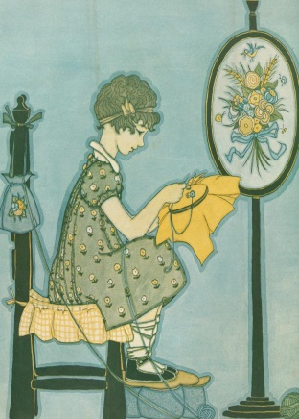CLASS 5 – Afghan

CLASS 6 – Afghan for baby crib

CLASS 7 – Lap Robe

**SECTION 9 - KNITTING**

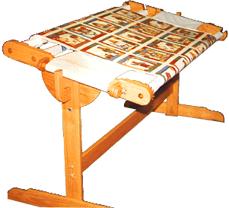

CLASS 1 – Infant’s set

CLASS 2 – Child’s sweater

CLASS 3 – Baby shawl

CLASS 4 – Adult’s sweater

CLASS 5 – Slippers, 1 pair

CLASS 6 – Novelty of any kind

CLASS 7 – Scarf

CLASS 8 – Mitts any size/Socks any size

CLASS 9 - Any other knitted item

**SECTION 10 - SEWING**

CLASS 1 – Child’s garment

CLASS 2 – Adult’s garment

CLASS 3 – Lap quilt

CLASS 4 – Any other item

CLASS 5 – Baby Quilt

**SECTION 11 - ANNUAL MACHINE QUILTED COMPETITION CLASS**

PRIZE

$15.00

CLASS 1 – Machine-quilted quilt **RULE:** Made & machine quilted by exhibitor. Perimeter measurement – minimum 324 in.

**Name of pattern

**SECTION 12 – ANNUAL HAND QUILTED COMPETITION CLASS**

PRIZE

$15.00

CLASS 1 – Hand-quilted quilt **RULE:** Made & hand-quilted by the exhibitor. Perimeter measurement – minimum 324 in

**Name of pattern

**NOTE:** The winning quilt of each class will be entered in the Oct. District 14 Competition. Winner from this can proceed to O.A.A.S. Championship Quilt Convention in Toronto in Feb. of the following year.

**SECTION 13 – SPINNING ADVANCED**

CLASS 1 – Any yarn, single ply, any technique

CLASS 2 – Any yarn, 2-ply (medium)

CLASS 3 – Exotic fibre (mohair, camel, silk, etc…)

CLASS 4 – **Novice**, someone who has been spinning less than 1 year. Any single ply, any two

CLASS 5 – Hand spun shawl or scarf

CLASS 6 – Hand spun sweater, adult size

CLASS 7 – Hand spun sweater, child size

CLASS 8 – Mitts & Socks CLASS 9 – Any item not listed

ply, exotic fibre, novelty yarn.

**SECTION 14 - WEAVING**

CLASS 1 – Garment of any fibre

CLASS 2 – Home furnishing, any item

CLASS 3 – Novelty item, any fabric

CLASS 4 – Novice (someone who has been weaving for less than 1 year). Tea towel, blanket,

throw.

CLASS 5 – Scarves or accessories (shoe laces, ties, belts, etc…)

CLASS 6 – Table item (napkins, place mats, etc…)

CLASS 7 – Yard goods, stating fibre content & intended use

CLASS 8 – Any item not listed. Rugs etc.

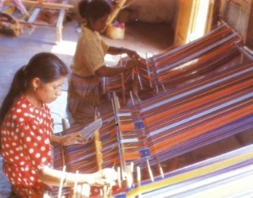**SECTION 15 - FELTING**

CLASS 1 – Household item

CLASS 2 – Wearable item (slippers, mitts, etc…)

CLASS 3 – Any item not listed

CLASS 4 – Wet felting

CLASS 5 – Nuno felting

CLASS 6 – Needle felting

**SECTION 16 - HOME CRAFTS (55 YRS & OVER)**

CLASS 1 – Drawing & painting, any media

CLASS 2 – Sewing, any item

CLASS 3 – Weaving, any item

CLASS 4 – Knitting, any item

CLASS 5 – Crochet, any item

CLASS 6 – Needlework, any item

CLASS 7 – Quilting, any item

CLASS 8 – Hobbies

CLASS 9 – Theme project (Xmas, Easter, etc…)

CLASS 10 – Floor rug, mat, etc…

CLASS 11 – Miscellaneous

CLASS 12 – Woodwork, any item (Wood turning)

CLASS 13 – Any item made from recycled material

CLASS 14 – Scrapbooking page

CLASS 15 – Jewellery (Handmade)

**SECTION 17 - HOME CRAFTS (22 YRS TO 54 YRS OLD)**

CLASS 1 – Wood working, wood turning

CLASS 2 – Painted T-shirt or Sweat-shirt

CLASS 3 – Any stuffed item

CLASS 4 – Jewellery (Handmade)

CLASS 5 – Knitting, any item

CLASS 6 – Ceramic item, stained and glazed

CLASS 7 – Drawing & painting, any media

CLASS 8 – Any quilted item

CLASS 9 – Miscellaneous

CLASS 10 – Wreath, any theme

CLASS 11 – Any item made from recycled material

CLASS 12 – Scrapbooking page

CLASS 13 – Decorated door hanging

**SECTION 18 - CRAFTS & HOBBIES (5 YRS – KINDERGARDEN)**

CLASS 1 – Paper plate mask

CLASS 2 – Item made from Lego Blocks ** no bigger than 15 in. square**

CLASS 3 – Holiday decoration (Xmas, Easter, etc…)

CLASS 4 – Finger painting artwork

CLASS 5 – Teddy Bear dressed up for any occasion

CLASS 6 – Item made from recycled material

CLASS 7 – Scrapbooking

CLASS 8 - Miscellaneous

**SECTION 19 - CRAFTS & HOBBIES (6 TO 11 YRS OLD – GRADE 1 TO GRADE 6)**

CLASS 1 - *Paint by number* painting

CLASS 2 – Jewellery

CLASS 3 – Item made from a kit

CLASS 4 – Needlework, embroidery, etc…

CLASS 5 – Item made from wood kit

CLASS 6 – Holiday decoration (Xmas, Easter, etc…)

CLASS 7 – Drawing & painting, any media

CLASS 8 – Collection, mounted, labelled (12+ items)

CLASS 9 – Item made from Lego Blocks **no bigger than 15in. square**

CLASS 10 – Lego construction made from a kit

CLASS 11 – Item made from recycled material

CLASS 12 – Scrapbooking page

CLASS 13 – Miscellaneous

**SECTION 20 - CRAFTS & HOBBIES (12 TO 17 YRS OLD – GRADE 7 TO GRADE 12)**

CLASS 1 – Dream catcher

CLASS 2 – Scrapbooking page

CLASS 3 – Jewellery

CLASS 4 – Item made from a kit

CLASS 5 – Item made from wood, hand painted

CLASS 6 – Item made from Lego Blocks **no bigger than 15in. square**

CLASS 7 – Knitted item

CLASS 8 – Artwork, hand drawn

CLASS 9 – Drawing & painting, any media

CLASS 10 – Item made from recycled material

CLASS 11 – Rainbow loom item

CLASS 12 – Miscellaneous



**SECTION 21 - PHOTOGRAPHY (Taken in 2021-2022)**

**\*\* Must be 5”X7” ** NEW: NOT FRAMED!)**

**AMATEUR PHOTOGRAPHY**

CLASS 1 – Photo of winter scene

CLASS 2 – Photo of summer scene

CLASS 3 – Veggies growing in garden

CLASS 4 – Close-up of a flower

CLASS 5 – Photo of wild flowers in natural settings

CLASS 6 – Close-up of any subject

CLASS 7 – Photo of children with their pet

CLASS 8 – Most unusual photo

CLASS 9 – Photo of insect(s)

CLASS 10 –Photo of favourite sport

**SECTION 22 - BAKING (16 YRS & UNDER)**

CLASS 1 – Iced chocolate brownies with nuts (4)

CLASS 2 – Iced cupcakes made with white flour (4)

CLASS 3 – Peanut butter cookies (4)

CLASS 4 – Molasses cookies (4)

CLASS 5 – Oatmeal cookies (4)

CLASS 6 – Blueberry muffins made with white flour (4)

CLASS 7 – Old-fashioned fudge (sucre-à-la-crème) (4)

CLASS 8 – Miscellaneous

**SECTION 23 - CHOCOLATE CAKE**

CLASS 1 – The best chocolate 8in. or 9 in. layered cake, iced & frosted

**SECTION 24 - PLAIN CHOCOLATE CHIP COOKIES**

**(YOUTH, UP TO 15 YEARS OF AGE AS OF CURRENT YEAR)**

CLASS 1 – Eight (8) plain chocolate chip cookies (no nuts) and no larger than 3 in. (6.75cm) & no smaller

than 2 in. (5cm)

**NOTE: The winner of the chocolate chip cookies will be entered in the October District 14 Competition. The winner from this competition will then proceed to O.A.A.S. Fair Championship Chocolate Chip Cookies Competition held in Toronto in Feb. of the following year.**

**SECTION 25 - YEAST BREAD & ROLLS**

CLASS 1 – White loaf of bread (1)

CLASS 2 – Brown loaf of bread (1)

CLASS 3 – Rolls made with whole wheat flour (6)

CLASS 4 – Cinnamon buns (6)

CLASS 5 – 60% whole wheat bread (1)

CLASS 6 – Sweet bread (1)

CLASS 7 – Machine baked white bread (1)

CLASS 8 – Machine baked brown bread (1)

CLASS 9 – Gluten-free bread, any type (1)

CLASS 10 – Miscellaneous

**SECTION 26 - PASTRIES (DOUBLE HOME-MADE CRUST) –**Can be 5” pies

CLASS 1 – Apple pie (1)

CLASS 2 – Strawberry & rhubarb pie (1)

CLASS 3 – Blueberry pie (1)

CLASS 4 – Sugar pie (single home-made crust) (1)

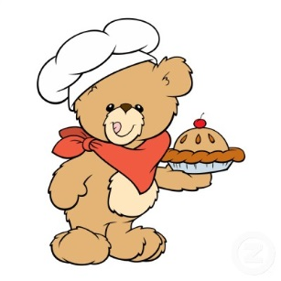CLASS 5 – Miscellaneous

**SECTION 27 - CAKE DECORATING**

CLASS 1 – Best decorated FAIR THEME cake (edible cake)

**SECTION 28 - BAKING (17 YRS & OLDER)**

CLASS 1 – Shortbread cookies (3)

CLASS 2 – Banana loaf with nuts (1)

CLASS 3 – Iced chocolate brownies with nuts (3)

CLASS 4 – Plain white flour tea biscuits (3)

CLASS 5 – Old fashioned fudge (sucre-à-la-crème) (3)

CLASS 6 – Date squares (3)

CLASS 7 – Plain butter tarts (no nuts, no fruits) (3)

Homemade pastry – Full size

CLASS 8 – Bran muffins with nuts (3)

CLASS 9 – Small fruit cake (1)

CLASS 10 – Zucchini loaf (1)

CLASS 11 – Miscellaneous

**Note: The winner of the butter tarts (class 7) will be entered in the October District 14 Competition. The winner from this competition will then proceed to O.A.A.S. Fair Championship Butter Tarts Competition held in Toronto in Feb. of the following year**

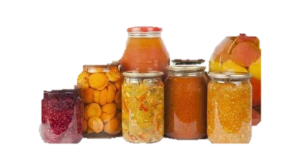**SECTION 29 – CANNING (NO WAX TO SEAL JAR –USE LABEL)**

**-**New lids –sealed

-Minimum size 8oz/250ml

CLASS 1 – Jar of strawberry jam (1)

CLASS 2 – Jar of crab apple jelly (1)

CLASS 3 – Jar of red pepper jelly (1)

CLASS 4 – Jar of blueberry jam (1)

CLASS 5 – Jar of raspberry jam (1)

CLASS 6 – Jar of dill pickles (1)

CLASS 7 – Jar of bread & butter pickles (1)

CLASS 8 – Jar of salsa (1)

CLASS 9 – Jar of chow-chow, red or green (1)

CLASS 10 – Jar of pickled eggs (1)

CLASS 11 – Jar of relish (no food colouring)

CLASS 12 – Jar of pickled beets (1)

CLASS 13 – Miscellaneous (1)

**NOTE:** All baked & canned items will be judged on: general & internal appearance, texture, home-made crust, flavour, aroma, filling.

**SECTION 30 - POULTRY, RABBITS & DUCKS**C:\Program Files (x86)\Microsoft Office\MEDIA\CAGCAT10\j0304933.wmf

CLASS 1 – Rabbit (buck & doe)

CLASS 2 – Doe with litter of rabbits

CLASS 3 – Angora rabbit (1)

CLASS 4 – Rabbit (any other breed) (1)

CLASS 5 – **GROWER PROGRAM** Rabbit

CLASS 6 – **CHICK PROGRAM** -Hen & Rooster

PRIZE

1st - $10

2nd - $6

3rd - $4

CLASS 7 – **CHICK PROGRAM** -Best Coop

CLASS 8 – Meat bird (chicken) (1)

CLASS 9 – Rooster (1)

CLASS 10 – Hen (1)

CLASS 11 – Pair of chicken any breed (rooster and hen)

CLASS 12 – Pair of bantams (rooster and hen)

CLASS 13 – Pair of any other fowl (male and female)

CLASS 14 – Pair of ducks (duck and drake)

CLASS 15 – Pair of geese (gander and goose)

CLASS 16 – Turkey

CLASS 17 – **GROWER PROGRAM** one of any Turkey

CLASS 18 – Pair of pheasants (male and female)

**SECTION 31 - GOATS, SHEEP & HOGS**

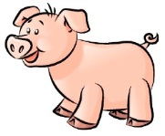

PRIZE

1st - $10

2nd - $6

3rd - $4

CLASS 1 – Doe, kid

CLASS 2 – Milking doe

CLASS 3 – Dry doe

CLASS 4 – Angora doe, kid

CLASS 5 – Lambs

CLASS 6 – **GROWER PROGRAM** Lamb (1)

CLASS 7 – Hogs

CLASS 8 – **GROWER PROGRAM** Hog (1)

**SECTION 32 - LIVESTOCK**

PRIZE

1st - $25

2nd - $12

3rd - $8

CLASS 1 – Dairy calf, under 2 years old

CLASS 2 – Beef calf, under 1 year old

CLASS 3 – Beef calf, under 2 years old

CLASS 4 – Steers, under 1 year old

CLASS 5 – Steers, under 2 years old

CLASS 6 – Dairy cow, milking

CLASS 7 – Beef cow

**C:\Program Files (x86)\Microsoft Office\MEDIA\CAGCAT10\j0149627.wmfCOCHRANE DISTRICT CATTLEMEN’S ASSOCIATION (CDCA)**

A prize of $50 will be given to the **BEST CALF** born in 2023, shown at the Fair.

Cheque will be mailed to the winner by **CDCA** and the **Ontario Cattlemen’s Association.**

**Section 33 – OAAS Poster Competition * Junior, Intermediate and Senior \***

CLASS 1 – Junior Original handmade design poster

Class 2 – Intermmediate Original handmade design poster

Class 3 - Senior Original handcrafted design poster